**Data science Exam Paper**

**Name :- MUSKAN SABHARWAL Roll Number:- 1810991650**

Q-Write a SQL query which will sort out the customer and their grade who made an order. Every customer must have a grade and be served by at least one seller, who belongs to a region.

**Ans 1:-**

**use exam;**

**select * from orders;**

**select * from Customer;**

**select * from salesman;**

**SELECT customer.cust_name AS "Customer",**

**customer.grade AS "Grade"**

**FROM orders, salesman, customer**

**WHERE orders.customer_id = customer.custemor_id**

**AND orders.salesman_id = salesman.salesman_id**

**AND salesman.city IS NOT NULL**

**AND customer.grade IS NOT NULL;**

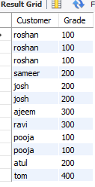

Q2. Write a query for extracting the data from the order table for the salesman who earned the maximum commission.

**Ans 2:-**

**SELECT ord_no, purch_amt, ord_date, salesman_id**

**FROM orders**

**WHERE salesman_id IN(**

**SELECT salesman_id**

**FROM salesman**

**WHERE commision = (**

**SELECT MAX(commision)**

**FROM salesman));**

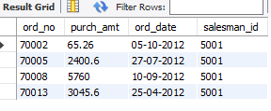

Q-From orders retrieve only ord_no, purch_amt, ord_date, ord_date, salesman_id where salesman’s city is Nagpur(Note salesman_id of orderstable must be other than the list within the IN operator.)

**Ans 3:-**

**SELECT \***

**FROM orders**

**WHERE salesman_id =**

**(SELECT salesman_id**

**FROM salesman**

**WHERE city='nagpur');**

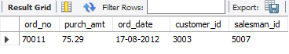

Q-Write a query to create a report with the order date in such a way that the latest order date will come last along with the total purchase amount and the total commission for that date is (15 % for all sellers).

**Ans 4:-**

**SELECT ord_date, SUM(purch_amt),**

**SUM(purch_amt)*.15**

**FROM orders**

**GROUP BY ord_date**

**ORDER BY ord_date;**

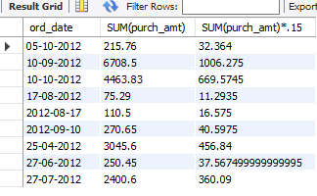

Q-Retrieve ord_no, purch_amt, ord_date, ord_date, salesman_id from Orders table and display only those sellers whose purch_amt is greater than average purch_amt

**Ans 5:-**

**SELECT \***

**FROM orders a**

**WHERE purch_amt >**

**(SELECT AVG(purch_amt) FROM orders b**

**WHERE b.customer_id = a.customer_id);**

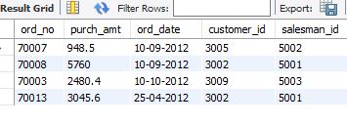

6. Write a query to determine the Nth (Say N=5) highest purch_amt from Orders table. 7. What are Entities and Relationship

**Ans 6:-  
select * from orders order by purch_amt desc limit 5;**

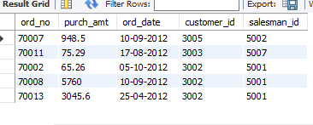

Q-What are Entities and Relationships?

**Ans 7:-**

**Entity:-**An entity set is a collection of similar types of entities. An entity set may contain entities with attribute sharing similar values. For example, a Students set may contain all the students of a school; likewise a Teachers set may contain all the teachers of a school from all faculties.

**Relationship:-**The association among entities is called a relationship. For example, an employee **works_at** a department, a student **enrolls** in a course. Here, Works_at and Enrolls are called relationships.

8. Print customer_id, account_number and balance_amount, condition that if balance_amount is nil then assign transaction_amount for account_type = "Credit Card"

**Ans 8:-**

Select customer_id , a.account_number,

Case when ifnull(balance_amount,0) = 0 then

Transaction_amount else balance_amount end  as balance_amount

from Bank_Account_Details a

inner join

bank_account_transaction b

on a.account_number = b.account_number

and account_type = "Credit Card";

9. Print customer_id, account_number, balance_amount, conPrint account_number, balance_amount, transaction_amount from Bank_Account_Details and bank_account_transaction for

**ANS 9:-**

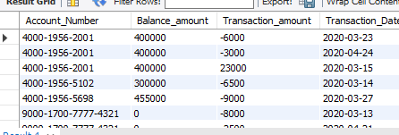

select a.account_number, balance_amount, transaction_amount, transaction_date

from bank_account_details a inner join

bank_account_transaction b on

a.Account_Number = b.Account_Number

and (Transaction_Date between "2020-03-01" and "2020-04-30")

10. Print all of the customer id, account number, balance_amount, transaction_amount from bank_cutomer, bank_account_details and bank_account_transactions tables where excluding all of their transactions in march, 2020 month

**ANS 10:-**

select a.Customer_id,a.account_number, balance_amount, transaction_date

from bank_account_details a left join

bank_account_transaction b on

a.Account_Number = b.Account_Number

and not (date_format(transaction_date, '%Y-%m')="2020-03") and Transaction_Date is not null